11th Legislative District Caucus & Nominating Convention

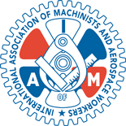
This caucuses shall be held on April 28, 2012 from 10:00 am to 1:00 pm. at the IAM 751 International Machinists and Aerospace headquarters 9125 15th Place South Seattle, WA 98108-5100.

Immediately following the adjournment of the 11th Legislative District’s Caucus, the Nominating Convention will convene.
The nominees for Washington State Senate and Washington State House of Representatives shall be chosen at a legislative district nominating convention consisting of elected and appointed precinct committee officers representing precincts in that legislative district.

Azziem
Azziem Hassan Underwood, Chair
11th Legislative District

